Room D
DQ1 Severe colitis & Toxic Megacolon
Stem: 36 yo male presents to the ER with abdominal pain, distention, nausea/emesis, bloody diarrhea, and fever that has been present for 3 days.
Last colonoscopy was 2 years ago with no dysplasia on biopsies and no other surgical history. He notes no recent travel, sick contacts, recent illnesses, or antibiotic usage.
On arrival, he is in significant pain.
PMH: Ulcerative colitis and has not been able to afford his medications due to insurance issues.
Vitals: HR 120s, BP 115/70.
On exam: diffusely tender, distention, voluntary guarding but no rigidity.
Labs: WBC 33, Hgb 9.5, Cr 1.6.
ER obtained a KUB which showed no pneumoperitoneum, dilated loops of small and large bowel.

What is your Differential Diagnosis:
- Ulcerative colitis exacerbation
- Toxic megacolon
- Infectious colitis (shigella, salmonella, E coli)
- C diff colitis
What would you like to do now?
- NPO, resuscitation, NG decompression
- Serial abdominal exams
- CT scan:
  - Diffuse dilation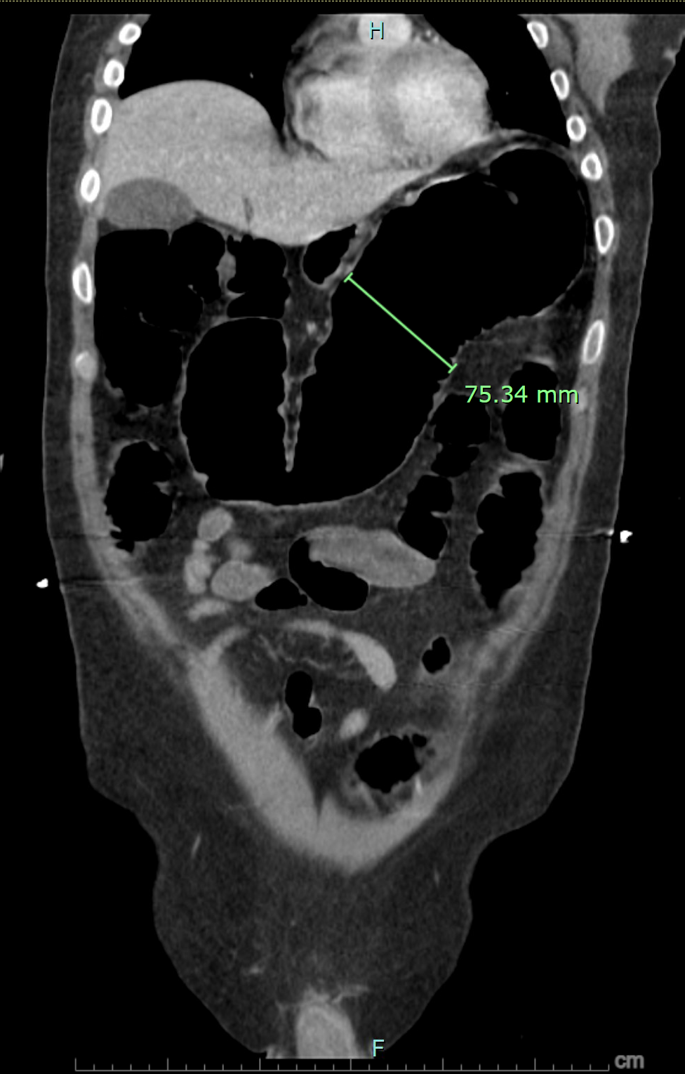

- C diff stool toxin, stool Cx, blood Cx.
- Colonoscopy …. Who will do the colonoscopy (Resident must answer me, if says GI answer is that they refused)
  - Why colonoscopy? Obtain biopsies (Rule out CMV colitis)
  - Describe how you will do it?

- Serial abdominal x-rays
- IV antibiotics,
- GI consultation
- Steroids (100mg hydrocortisone q 6-8 h)
- Add infliximab or cyclosporine if not responding to IV steroids after 48-72 hours.

Scenario Continues: Patient fails to improve after ~72 hours? What would you like to do now?

- Go to OR

- Explain Steps, ( To examiner : Procedure can be either open subtotal colectomy or laparoscopic subtotal colectomy, if lap patient develops stool spillage after handling the colon, difficult to control, need to ex.lap. )

- - Ex.lap
- - Subtotal colectomy with end ileostomy, leaving long rectal stump for future procedures.
- - End ileostomy.
- - Rectal stump can be brought out as mucus fistula or drained with rectal drain (Risk of rectal stump dehiscence).

Patient does well afterwards, follows with GI as an outpatient and with you, he is now nutritionally optimized and off all meds, comes back to you desiring reversal, what procedure do you offer him?

Completion proctectomy and IPAA with diverting loop ileostomy followed by Ileostomy reversal in 3 months.

DQ2 Breast Ductal Papilloma
What is most likely diagnosis?
Stem: 59y postmenopausal female presenting with complaints of unilateral bloody nipple discharge from the right breast. Mammogram is unremarkable.

Intraductal papilloma

What would you like to do now?

- Ultrasound vs MRI vs contrast ductography: US demonstrated a dilated duct in the right periareolar area

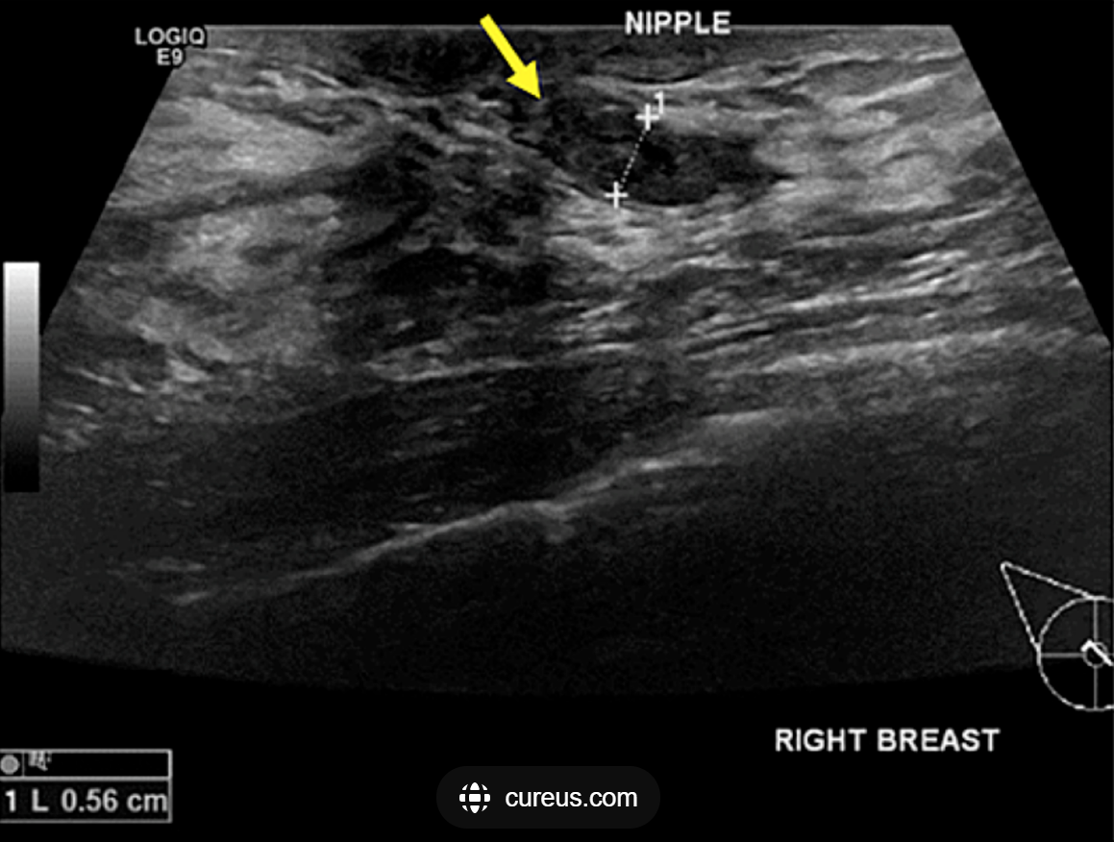

- Ultrasound guided biopsy: indeterminate

- OR:

Describe:

- Terminal duct excision/excisional biopsy
- Insert a fine lacrimal duct probe into the dilated duct.
- Make a periareolar incision (no more than 30% circumference
- Isolate the affected duct
- Resect the subareolar region with the abnormal duct attempting to preserve unaffected duct(s) if possible.

- Pathology : Confirming.

DQ3 Boerhaave’s Esophagus / Esophageal Spontaneous Perforation.
Stem: You are called to see a 67 y.o. male in E.R., presenting with acute chest and epigastric pain after 3 hrs of vomiting. He is known to ER team with prior visits due to ETOH intoxication
No further history is availble.
On exam he is ill appearing.
HR 115, BP 95/75, RR 28, SaO2% 89% on 2L NC.
He has diminished breath sounds bilaterally.
His abdomen is slightly distended but soft.

What is your differential diagnosis?
- Perforated esophagus
- MI
- Perforated duodenal ulcer
- Pancreatitis
- Pneumonia
What would you want to do now?
- Resuscitation - Establish 2 large bore IVs, IV resuscitation
- Broad spectrum antibiotics, antifungals for lower esophageal perforations
- Foley.
- Labs: CBC, CMP, Lipase, Coag panel.

- Imaging:
  - CXR: Shows (pneumomediastinum, small left pleural effusion)
  - CT (Examiner: ask what type of contrast, should be with PO and IV): shows pleural effusion, fluid and air within the lower, posterior mediastinum.
  - Esophagram: Distal extravasation of contrast.
Esophagram is all needed preoperatively, but CT with PO and IV contrast is acceptable.
Would you perform an EGD? Yes ? If other imaging is inconclusive and suspicion for concurrent pathology or undiagnosed perforation is high.
Can you explain the steps of a routine EGD (Not on this patient) – Even if the resident answered no.
- The endoscope is introduced into the mouth and to the base of the tongue under direct visualization.
- The vocal cords, epiglottis, both piriform sinuses, and cricoarytenoid cartilages are visualized
- The scope is then passed to the esophagus under direct visualization, often with application of gentle pressure while insufflating air.
- The scope is advanced down the esophagus lumen while simultaneously examining the mucosa
- The stomach is entered after passing the esophagogastric junction. –
- The endoscope is then advanced while torquing towards the pylorus, then the duodenal bulb.
- The scope is advanced to the second part of the duodenum,
- The endoscope is retroflexed to visualize the gastric cardia and fundus.
- The endoscope is then withdrawn.

In perforated esophagus, what are the indications for surgery?
- Free perforation
- Hemodynamic instability
- Uncontrolled sepsis
- Clinical deterioration.
- Early presentation.
Scenario: Your junior colleague calls you from the OR for advice, his patient presented more than 24 hours from the perforation, he is in the OR now with the patient for clinical deterioration, intraoperatively she found segment of devitalized tissue of the esophagus what would you advise him to do?
Resection and delayed reconstruction versus Diversion and total exclusion
- End cervical esophagostomy "spit fistula"
- Stapling or ligation of the distal cervical esophagus
- Ligation of the GE junction
- Gastrostomy: Why? To prevent GE reflux into esophagus.
- Jejunostomy tube for feeding
How would then restore esophageal continuity in the future? Colon conduit

Scenario: if the patient is presented within 24 hours of the perforation, the perforation is at the distal esophagus) above the diaphragm. How would you perform the surgery?
- EGD in OR (gently) to rule out any primary problems.
- Approach: L thoracotomy through 6th or 7th interspace for distal third perforations. Preserve intercostal flap while entering chest.
- Open the mediastinal pleura from the diaphragm to the thoracic inlet over the perforation.
- Dissect muscle injury proximally and distally to find the definite edges of the mucosal perforation.
- Three layer closure over NGT tube placed intraoperatively: Mucosa with absorbable suture, muscle as a separate layer followed by intercostal (preferred), diaphragmatic, pericardial fat, pleural.
5. Wide drainage (2-3 chest tubes)
6. Perform G tube (open, lap, or PEG via push technique)

- Stenting of small perforations is reasonable on this exam. The chest must still be cleaned out and drains placed if there is spillage through the perforation. (Dr. Speicher)

What’s the approach for
- Cervical esophageal perforation? Left neck incision anterior to SCM
- Proximal/Upper 2/3rd Perforation? Right thoracotomy
- Abdominal Perforation? Upper midline incision

